**Test Question (30 minutes)**

Samuel interviews many candidates from different colleges using coding challenges and contests. Write a query to print the *contest_id*, *hacker_id*, *name*, and the sums of *total_submissions*, *total_accepted_submissions*, *total_views*, and *total_unique_views* for each contest sorted by *contest_id*. Exclude the contest from the result if all four sums are.

**Note:** A specific contest can be used to screen candidates at more than one college, but each college only holds screening contest.

# Input Format

The following tables hold interview data:

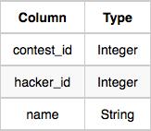*Contests:* The *contest_id* is the id of the contest, *hacker_id* is the id of the hacker who created the contest, and *name* is the name of the hacker.

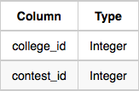*Colleges:* The *college_id* is the id of the college, and *contest_id* is the id of the contest that Samantha used to screen the candidates.

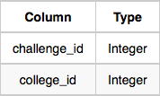*Challenges:* The *challenge_id* is the id of the challenge that belongs to one of the contests whose contest_id Samantha forgot, and *college_id* is the id of the college where the challenge was given to candidates.

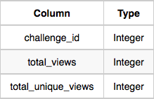*View_Stats:* The *challenge_id* is the id of the challenge, *total_views* is the number of times the challenge was viewed by candidates, and *total_unique_views* is the number of times the challenge was viewed by unique candidates.

*Submission_Stats:* The *challenge_id* is the id of the challenge, *total_submissions* is the number of submissions for the challenge, and *total_accepted_submission* is the number of submissions that achieved full scores.

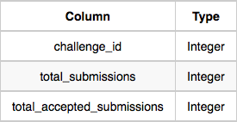

# Sample Input

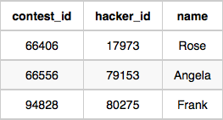*Contests* Table:

*Colleges* Table:

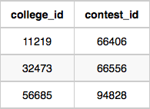

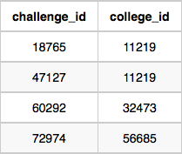*Challenges* Table:

*View_Stats* Table:

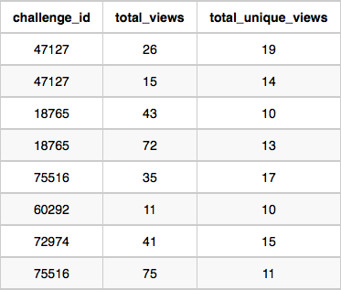

*Submission_Stats* Table:

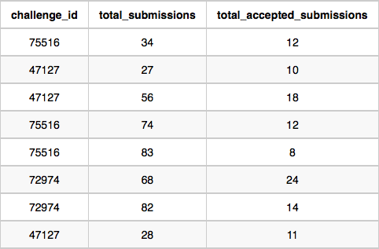

# Sample Output



66406 17973 Rose 111 39 156 56

66556 79153 Angela 0 0 11 10

94828 80275 Frank 150 38 41 15

**Explanation**

The contest  is used in the college  . In this college  , challenges  and  are asked, so from the *view* and *submission* stats:

Sum of total submissions 

Sum of total accepted submissions 

Sum of total views 

Sum of total unique views 

Simillarly, we can find the sums for contests  and .